**RFID Readers Configurations**

|  |  |  |  |
| --- | --- | --- | --- |
| S.No | RFID READER IP | URL | Distance |
| 1 | 192.168.1.106 | https://192.168.1.4:5005/tag_reader/read/plodder_1_a | -2 |
| 2 | 192.168.1.102 | https://192.168.1.4:5005/tag_reader/read/plodder_2_b | -2 |
| 3 | 192.168.1.103 | https://192.168.1.4:5005/tag_reader/read/chill_drum_a | -2 |
| 4 | 192.168.1.101 | https://192.168.1.4:5005/tag_reader/read/chill_drum_b | -2 |
| 5 | 192.168.1.105 | https://192.168.1.4:5005/tag_verifier/verify/mixer_a | -2 |
| 6 | 192.168.1.104 | https://192.168.1.4:5005/tag_verifier/verify/mixer_b | -2 |
| 7 | 192.168.1.107 | https://192.168.1.4:5005/tag_reader/read/plodder_1_a | -2 |
| 8 | 192.168.1.108 | https://192.168.1.4:5005/tag_reader/read/plodder_2_b | -2 |

HMIS URLS

|  |  |  |
| --- | --- | --- |
| S.NO | URL | Static Ip |
| 1 | https://192.168.1.4:5005/?machine_ids=plodder_1_a | 192.168.1.160 |
| 2 | https://192.168.1.4:5005/?machine_ids=plodder_2_b | 192.168.1.161 |
| 3 | https://192.168.1.4:5005/?machine_ids=chill_drum_a,chill_drum_b | 192.168.1.162 |

**RFID Reader Reading distance**

-2 is the farthest and 250 is the Nearest

In the below first image we can see Reader Ip and Rf Parameter Options, At the Reader IP enter selected reader ip address from the above table. At the RF Parameter field enter Reading Distance between -2 to 250.

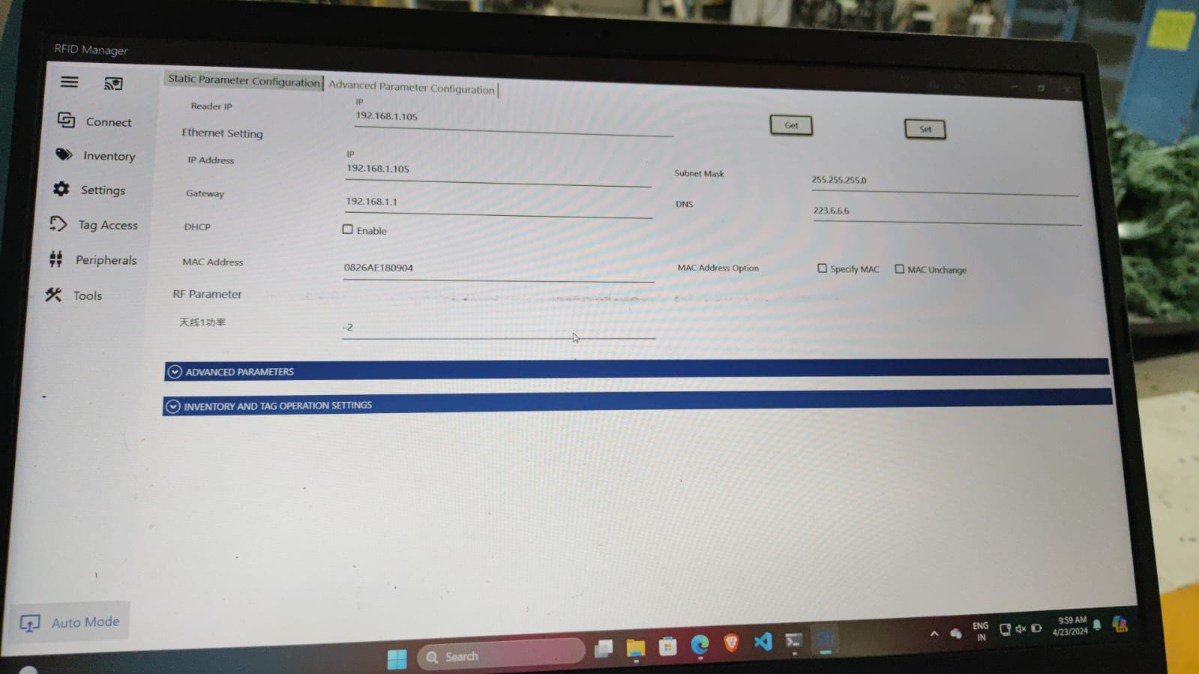

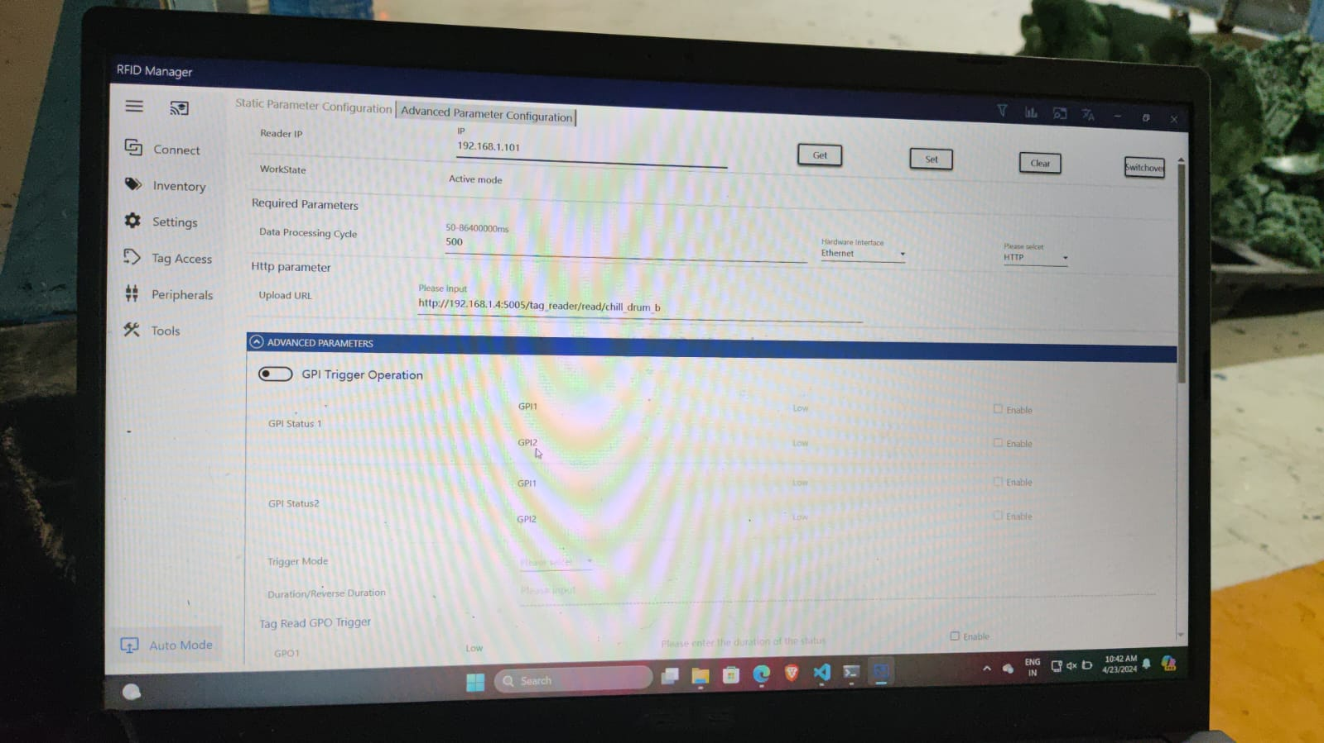

In the above Image there is a Reader Ip field,In that text field enter the RFID Reader Ip address and at Upload URL field enter the url as per the reader selection.